Link: <https://www.youtube.com/watch?v=twqnMwQf_-k&t=151s>

Create a job

Git – provide git link

Execute shell:

npm install

~~ng build –prod~~

ng build --configuration

mv /dist/client/* /var/www/html

Save

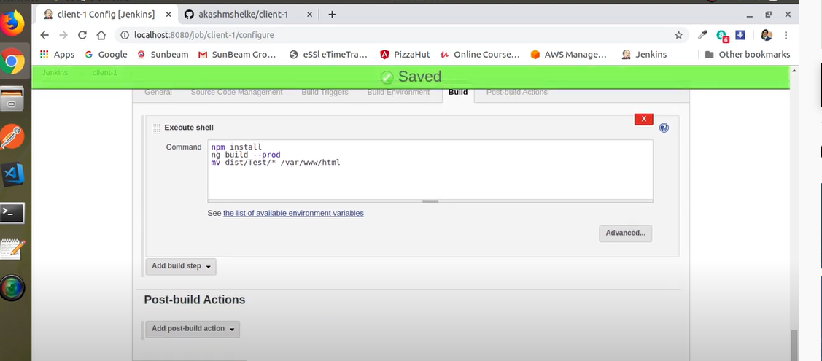

**NodeSource repository**

The simplest way to install Node.js and npm is from the **NodeSource repository**.

1. First, update the local repository to ensure you install the latest versions of Node.js and npm. Type in the following command:

sudo yum update

2. Next, add the NodeSource repository to the system with:

curl –sL https://rpm.nodesource.com/setup_14.x | sudo bash -

3. The output will prompt you to use the following command if you want to install Node.js and npm:

sudo yum install –y nodejs

4. Finally, verify the installed software with the commands:

node –-version

[centos@ip-172-31-17-193 ~]$ node --version

v14.18.3

[centos@ip-172-31-17-193 ~]$

sudo npm install -g @angular/cli@12.2.1 == keep same version